The Accounts Payable WorkCenter pages provide streamlined access to common accounts payable tasks. The use of the WorkCenter pages reduces navigation through CAPPS and can increase productivity by providing a central place to do day-to-day work.

Using the Accounts Payable WorkCenter
STEP 1
Navigate to the Accounts Payable > Accounts Payable WorkCenter

STEP 2
Look at the “My Work” section and Notice the Approvals, Processing, and Exceptions. These are basic queries that can be used to determine where in the process your Vouchers are.

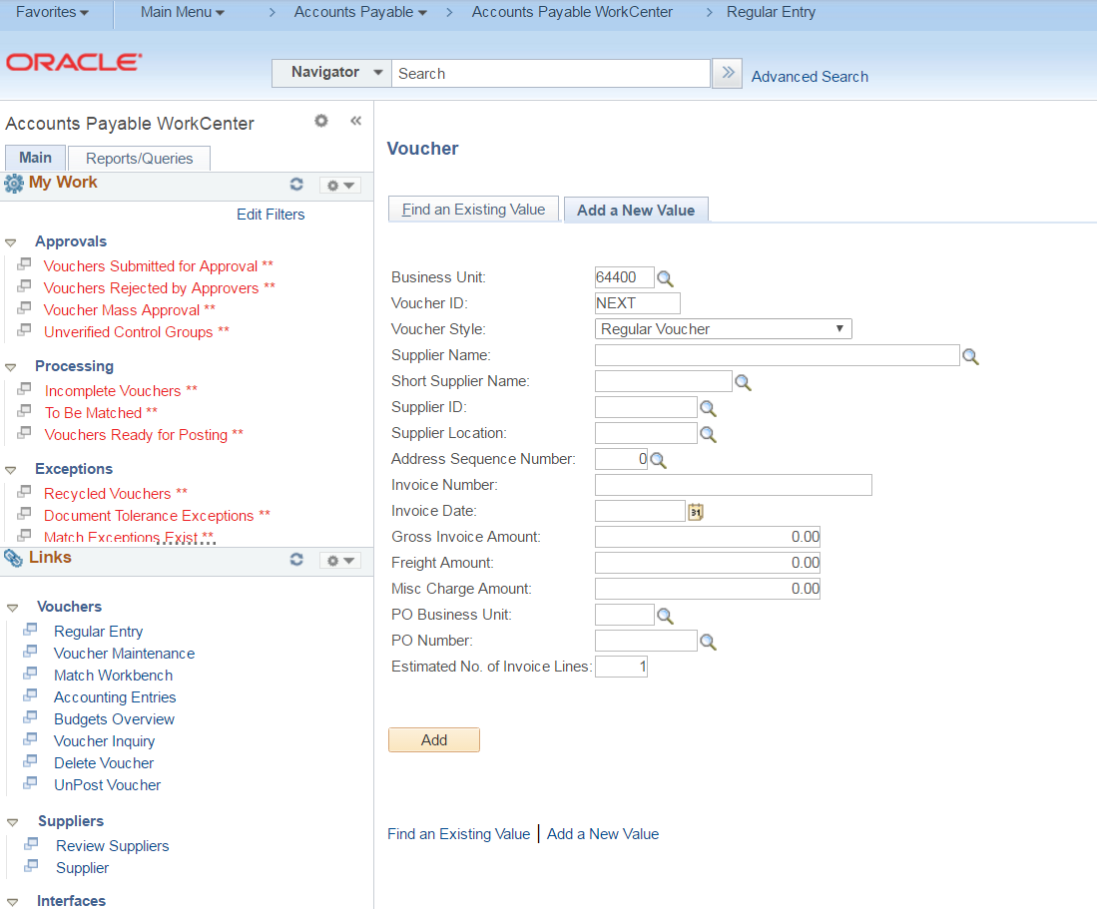

STEP 3
Click the “Edit Filters” link. This is used to set the parameters that you would like the Approvals, Processing, and Exceptions link to show.

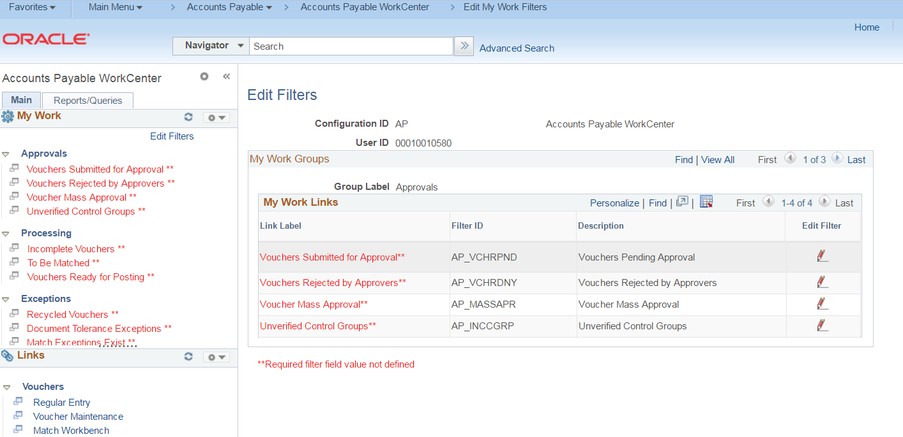

STEP 4
Click the “Edit Filter” Pencil to the right of the Vouchers Submitted for Approval.

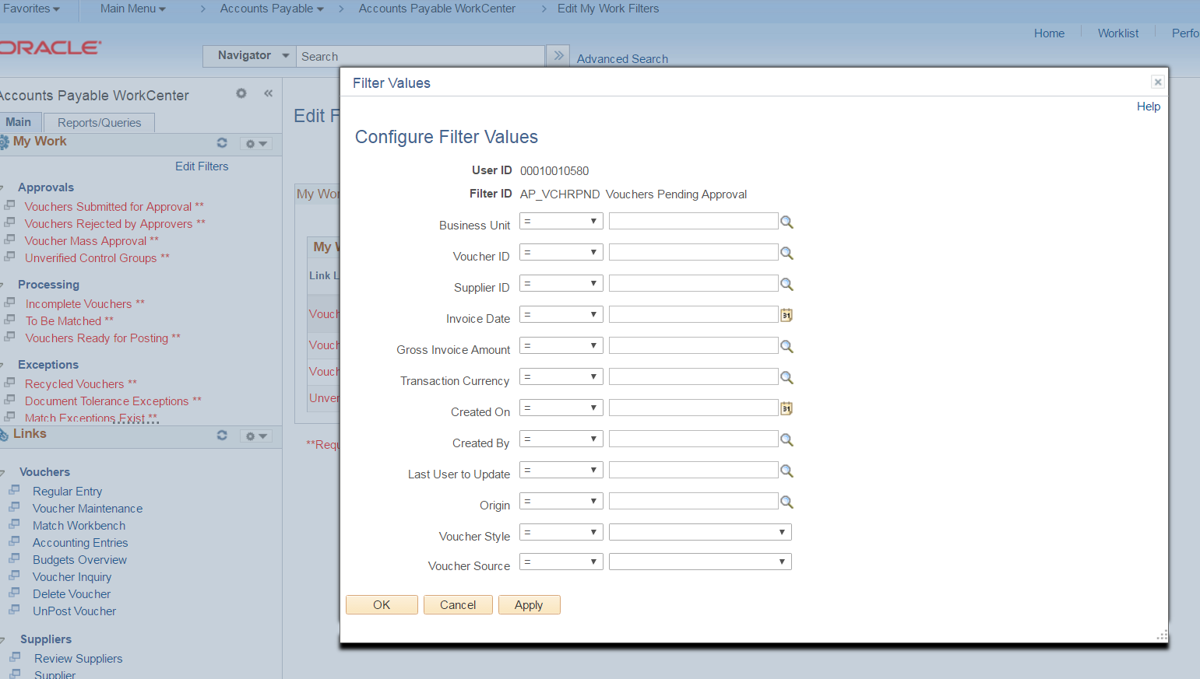

STEP 5
Enter the fields that you would like to filter on:
Business Unit (required to get results)
Created By (this would be optional if you only want to see only the vouchers that you created)

STEP 6
Click ‘OK’

STEP 7
Click ‘OK’ on the ‘Message’ popup.

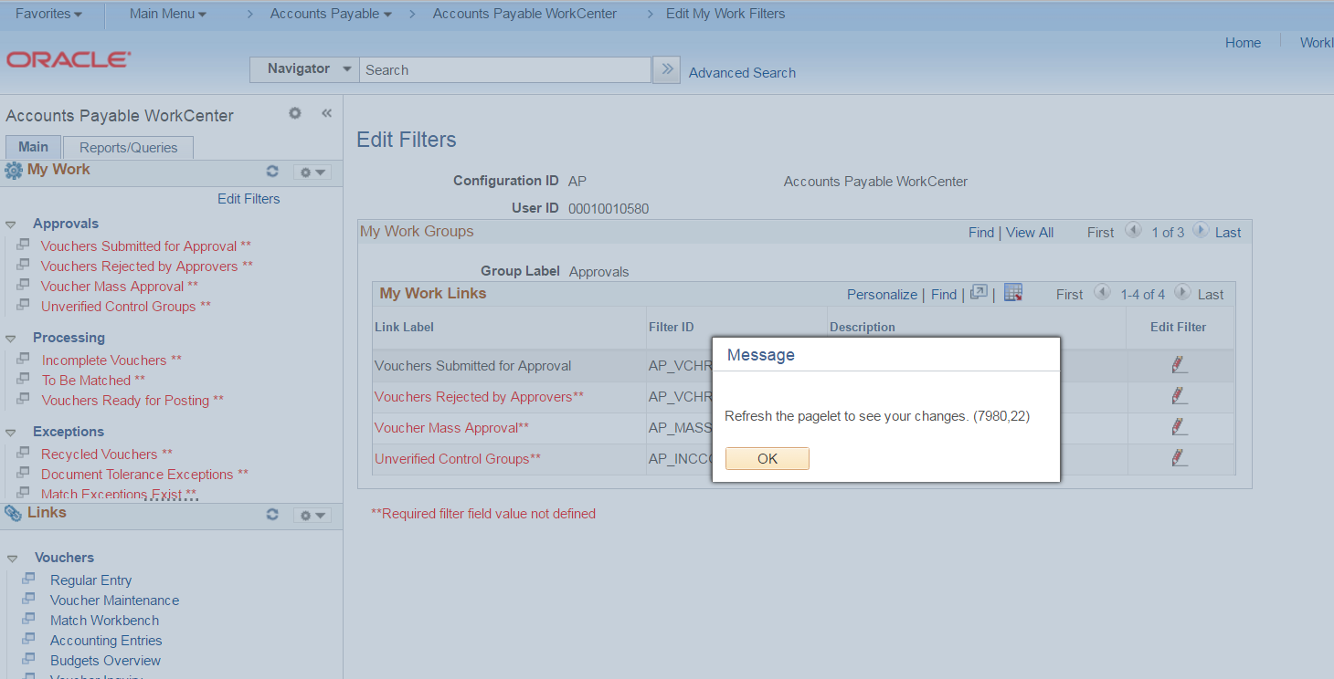

STEP 8
Notice that the Link Label has changed colors. This will indicate that a filter has been set.

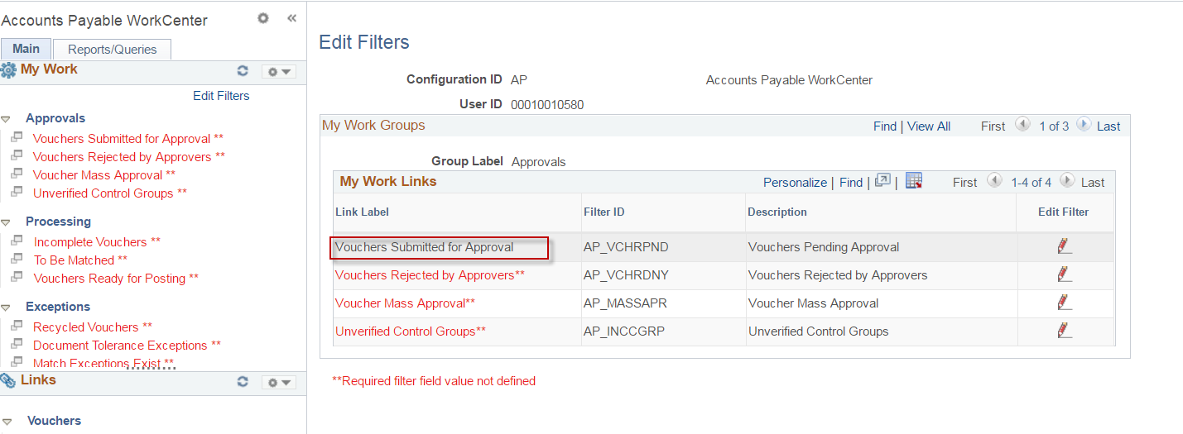

STEP 9
Click the ‘Refresh’ button.

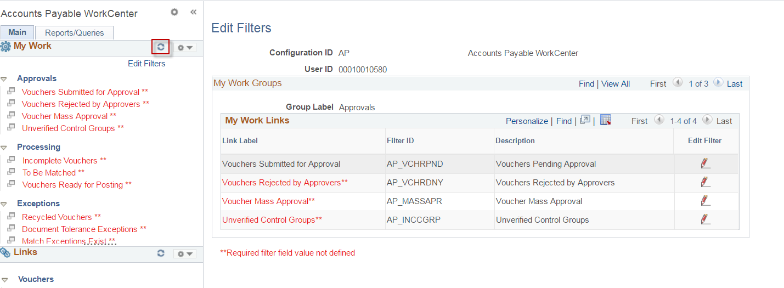

STEP 10
Notice that the link under “My Work” has changed colors to indicate that the filters have been set.

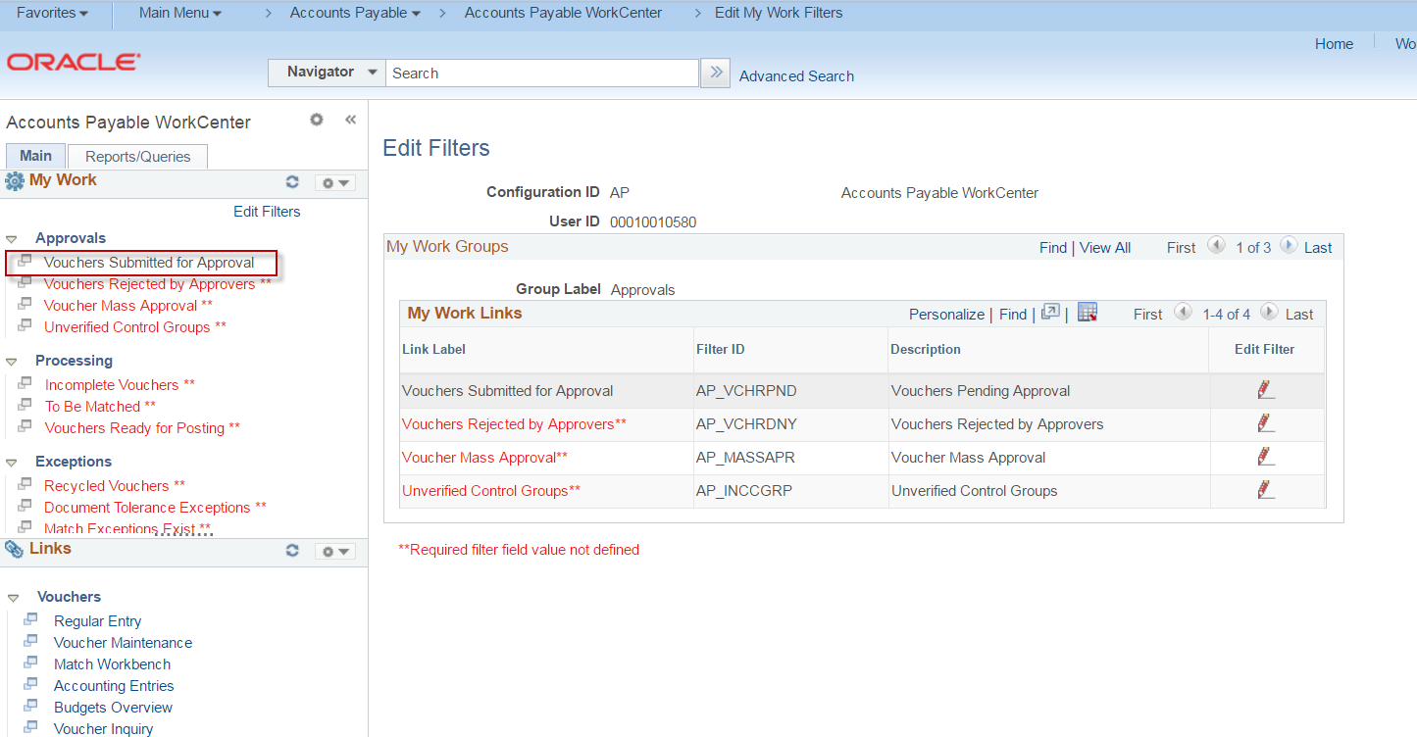

STEP 11
Perform Steps 3 thru 8 for all of the links under ‘Approvals’. Set the filters for each link. At a minimum, select your business unit.

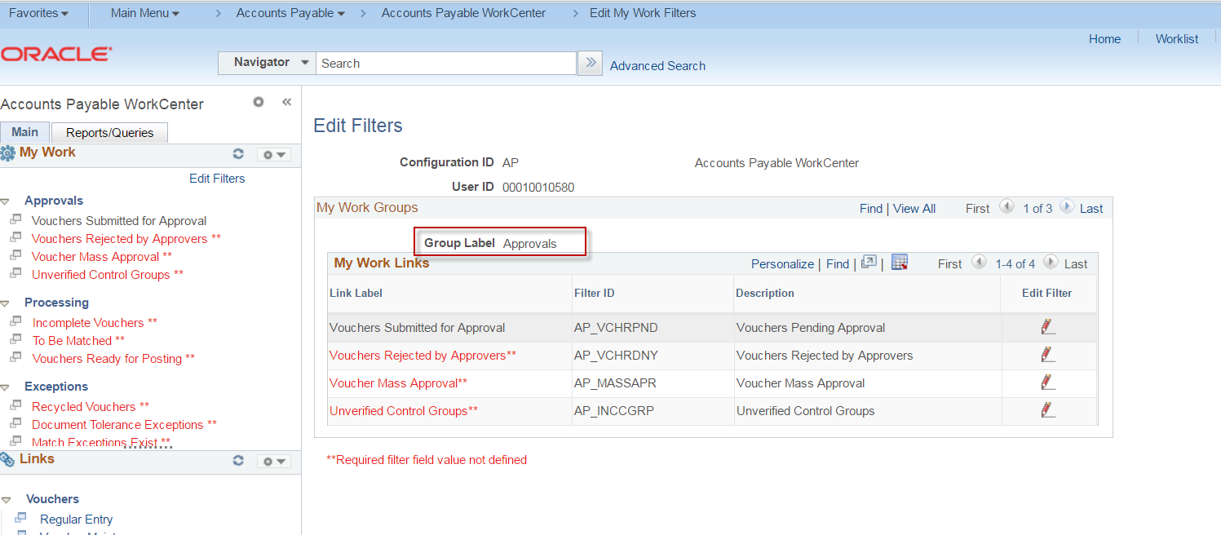

STEP 12
Click the > on the “My Work Groups” tab to go to the next Group Label.

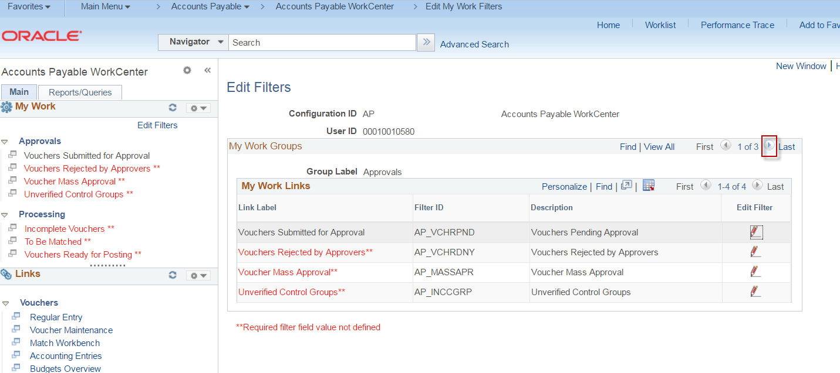

STEP 13
Perform Steps 3 thru 8 for all of the links under ‘Processing’. Set the filters for each link. At a minimum, select your business unit.

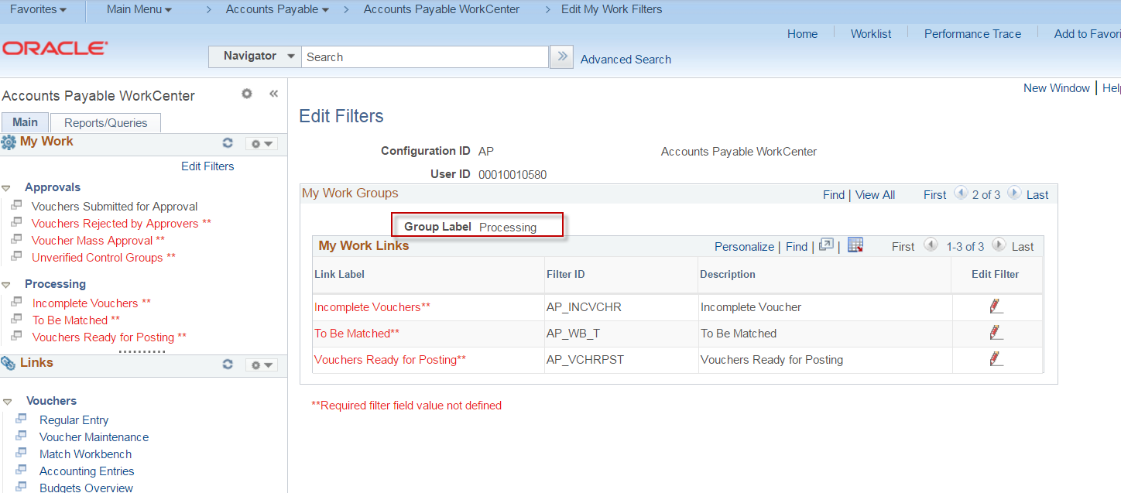

STEP 14
Click the > on the “My Work Groups” tab to go to the next Group Label.

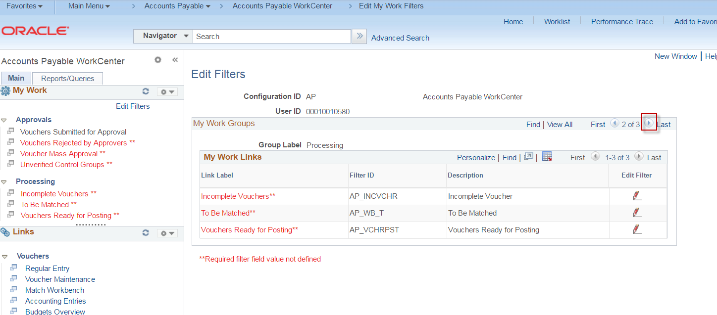

STEP 15
Perform Steps 3 thru 8 for all of the links under ‘Exceptions’. Set the filters for each link. At a minimum, select your business unit.

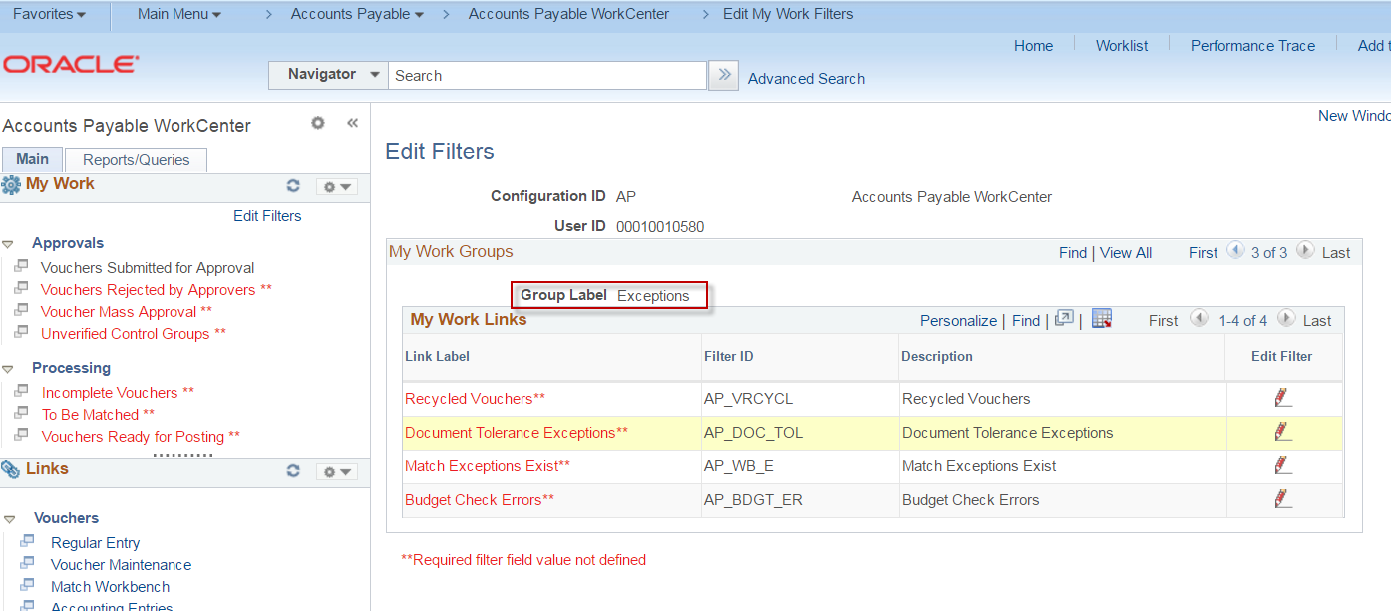

Note: Steps 3 thru 13 are 1 time setups, but can be changed as necessary.

STEP 16
Click the Accounts Payable WorkCenter in the thumbnails at the top of the page to get out of the filters page.

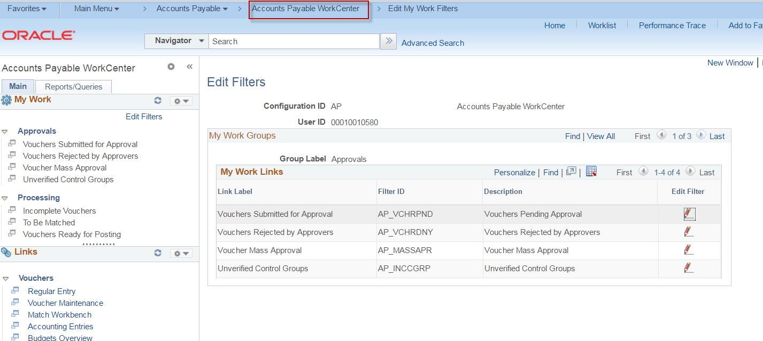

STEP 17
Notice the link labels under “My Work”. If there are vouchers that match the criteria set in the filters, the number of vouchers will appear and the link label will turn into an actual link.

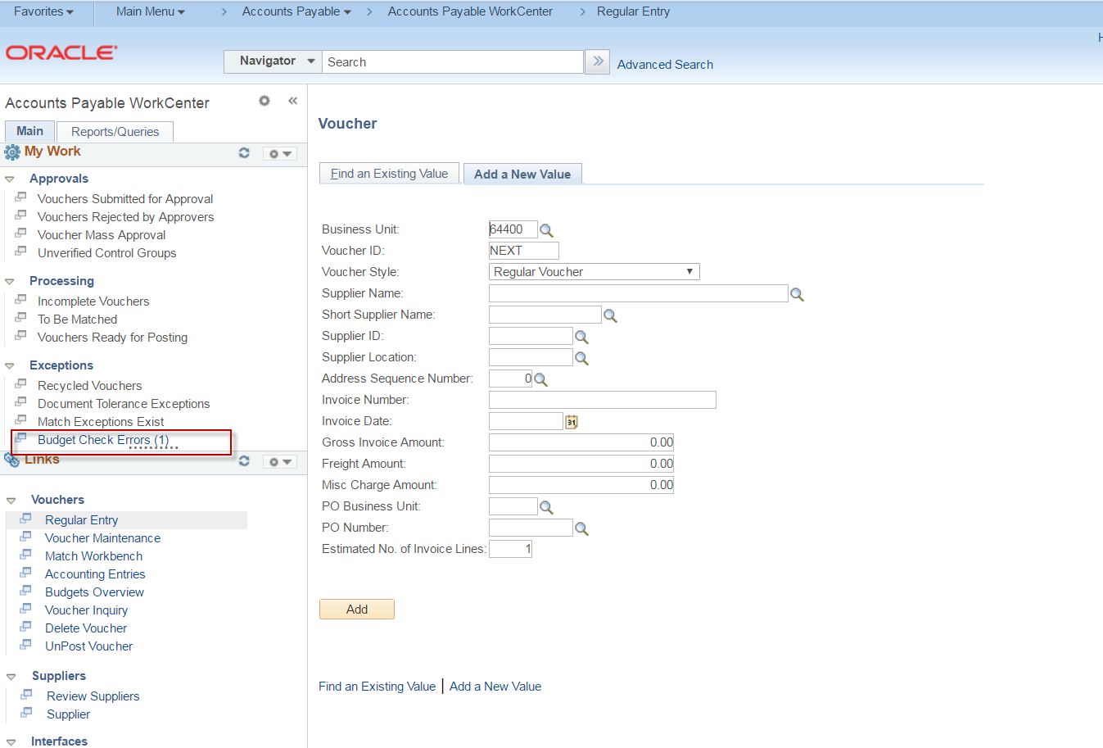

STEP 18
Click a link (if available) under the “My Work” to see the Vouchers that meet that Criteria. (In this example, the Budget Check Error link was chosen.

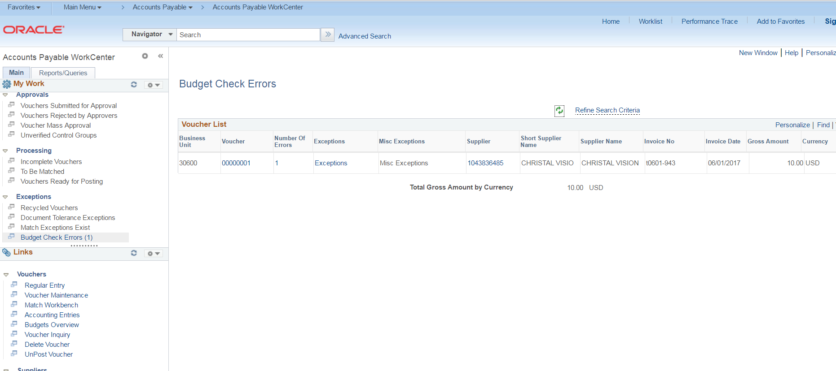

STEP 19
Click the Voucher link on the right (or any other link available) to see more detail.

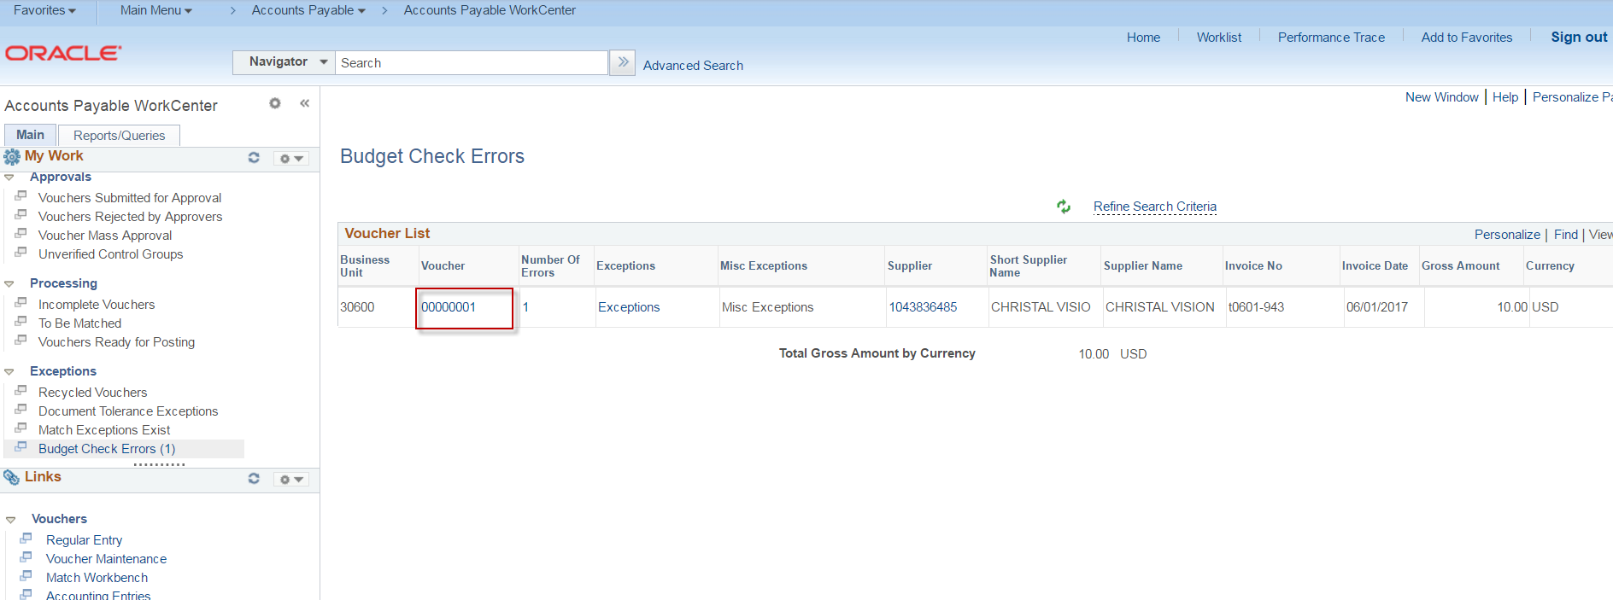

STEP 20
Notice the “Links” section on the left side of the WorkCenter. These links are the most common navigations in CAPPS. The links can be used as a shortcut without going through the regular navigation.

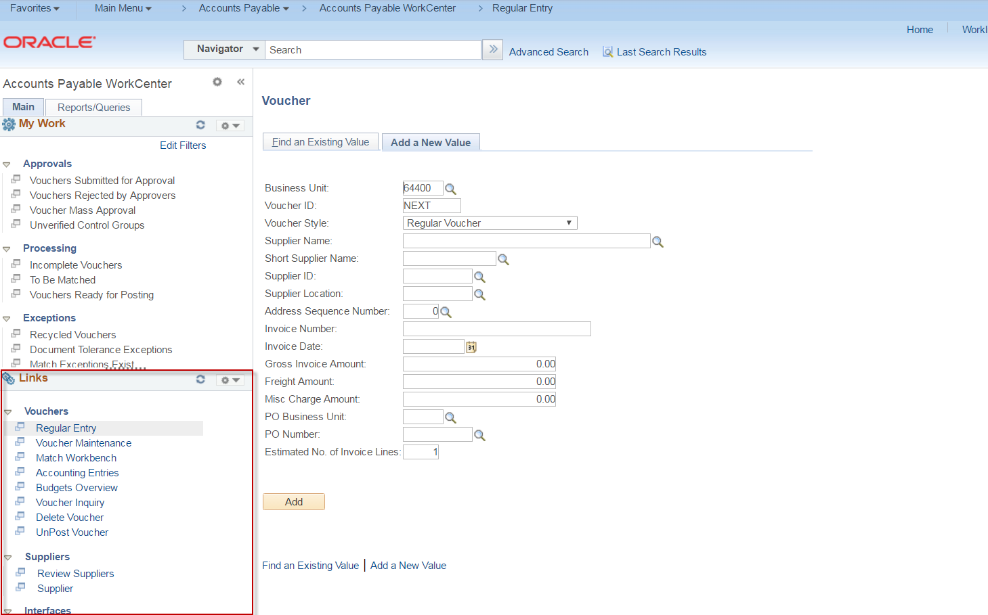

STEP 21
Click on the “Reports” tab in the Accounts Payable WorkCenter.

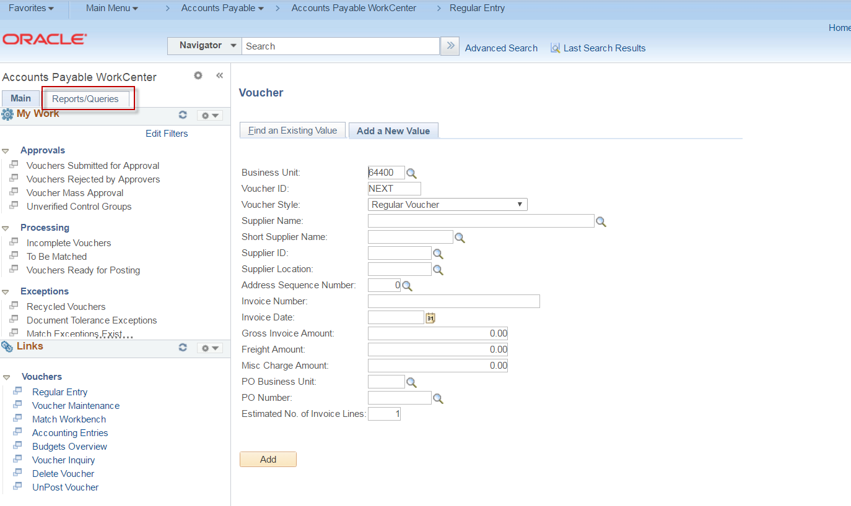

STEP 22
Notice all of the most common Accounts Payable Reports that are in CAPPS are located in the Reports/Processes section of the WorkCenter.

