Supplier- Add A New Supplier in CAPPS
- Suppliers > Supplier Information > Add/Update > Supplier
- Tab: Add a New Value
Enter: SetID
Enter: Supplier ID (Must be a valid TINS number)
Enter: Persistence (should always be “Regular”)
Click: Add
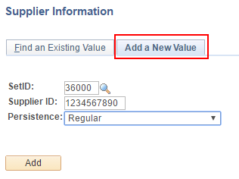
- Tab: Identifying Information
Enter: Supplier Name, Supplier Short Name
Verify: Classification is “Outside Party”
Verify: Persistence is “Regular”
Verify: “Open for Ordering” box is checked on
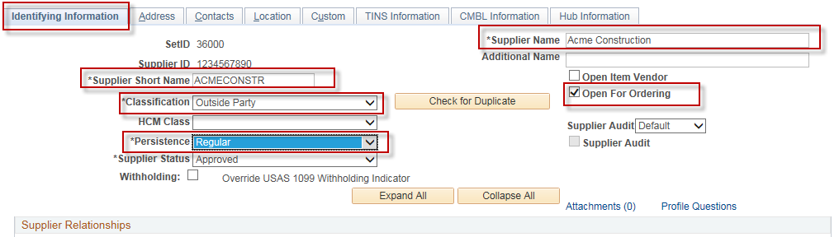
- Tab: Address
Enter: Description (Optional), Address 1, City, Postal (Zip), State
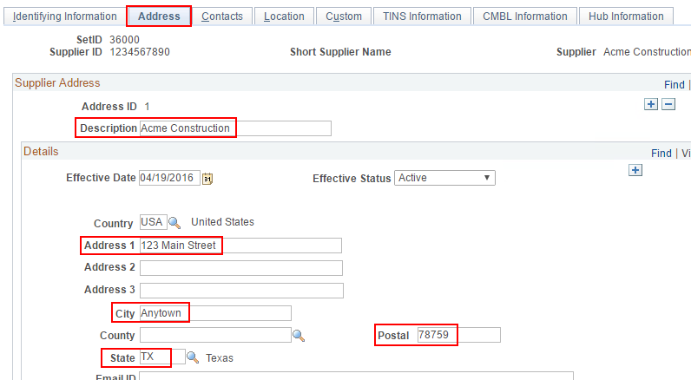
- Tab: Location
Enter: Location (Mailcode), Description
Verify: Address box is populated with “1”
Verify: Default box is checked on.
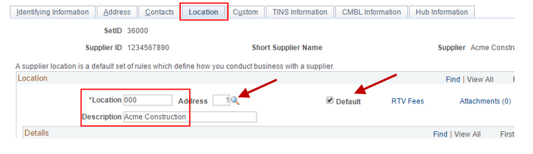

- Tab: TINS Information
Enter: In the Vendor Ownership Information section, enter Ownership Type and other required fields as required by Ownership Type
In the “Vendor Location Information” section, enter Location Name (name that will be displayed on the printed Voucher).
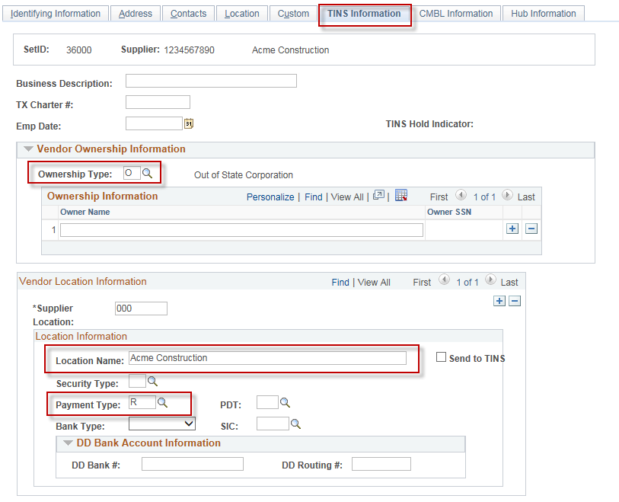
- Click: Save.

