Objective | Create a CAPPS Appropriation Transfer Journal and Post
Process | KK TBD
Transaction | 012 & 018 Budget Transfer
Navigation | Main Menu>Budget Transfer>Budget Journals>Enter Budget Journals

Step1 | Create a journal entry to be posted from the online page.
Action | Business Unit = 03200; Journal ID = NEXT; Journal Date = Today’s Date
 | Press ‘Add’

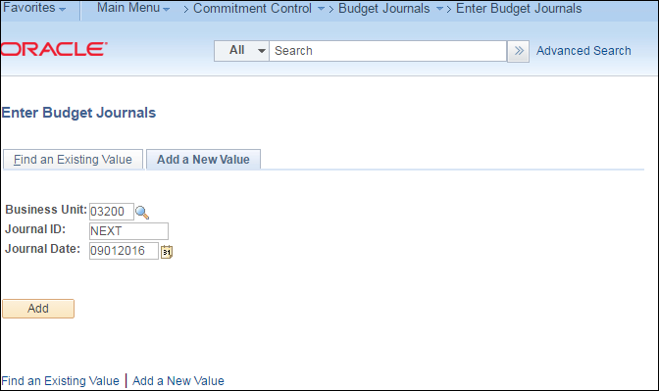

Step2 | Complete the Header information
Action | Ledger Group (APPROP)
 | Complete Long Description (optional)
 | Click on DLT Comments (optional based on USAS Tcode)
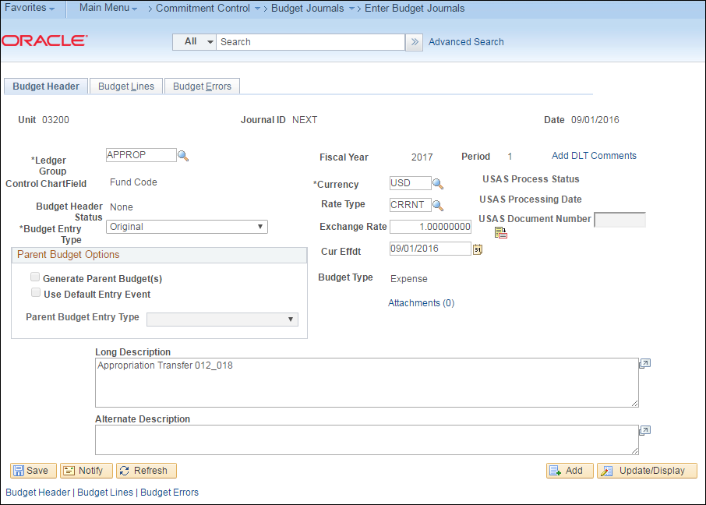

Action | Click on ‘Use Standard Comments’
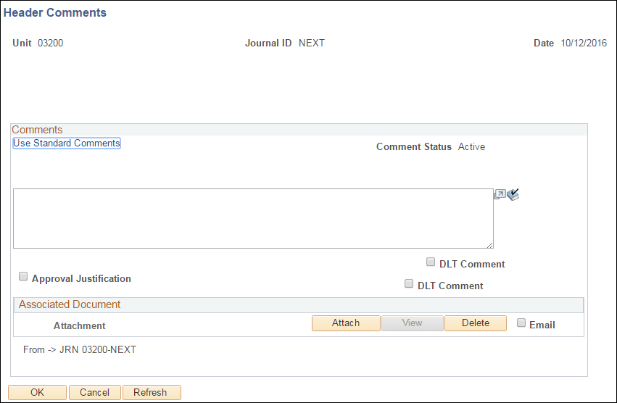

Action | Comment Type= DLT and Comment ID = DLT
 | This uses pre-determined DLT comments to load into Comments box.
 | Press OK twice and Click on Journal Lines Tab

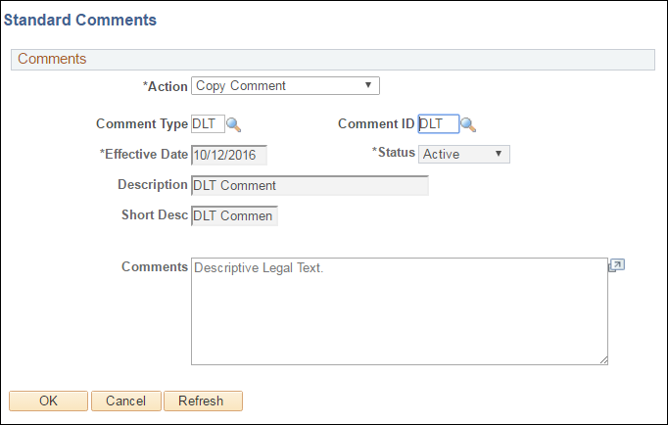

Step3 | Budget Lines Tab: Complete Lines information and Save the Journal Entry.
Action | Add Account, Fund, Approp, AY and Amount
 | T-Code = 012 Transfer Out
 | Press ‘+’ sign to add line: Copy down feature will populate most fields

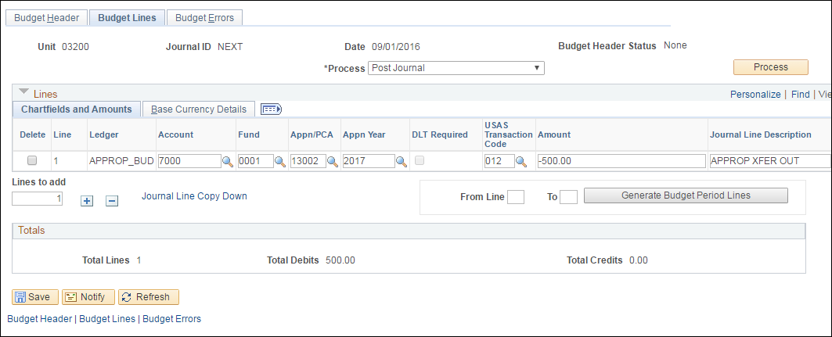

Action | Complete Line 2 with information the completes the transfer-in and Save

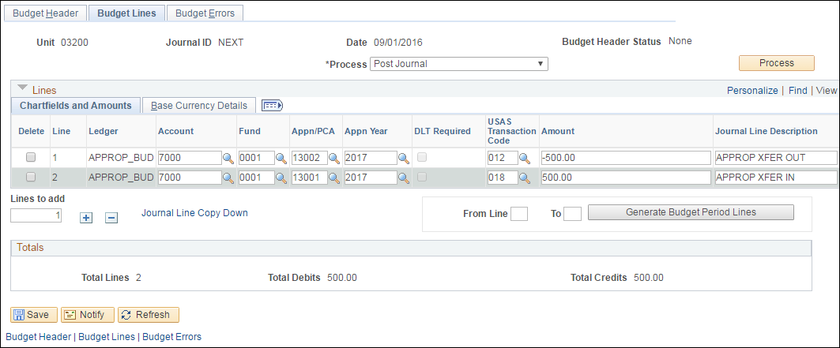

Step 3 | Select the “Post Journal” process and click the Process button to Post. A message will appear ‘Are you sure that you want to post this journal? (5010,45)’  Select Yes.
Action | Verify that the Budget Header Status = P.

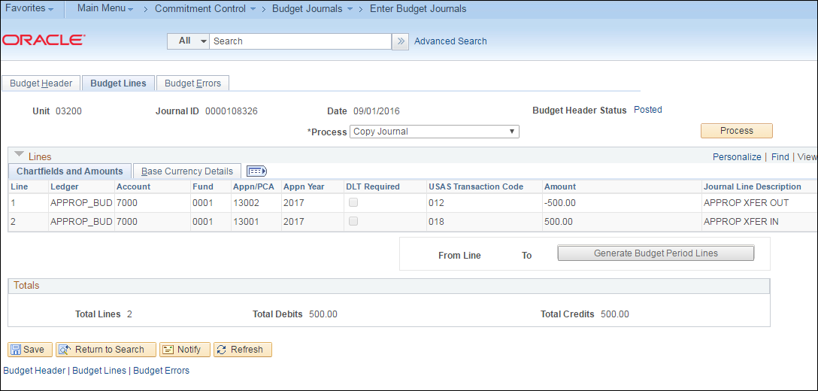

Step 4 | You may also run the posting process from the menu
Navigation | Commitment Control > Post Control Budget Journals> Request Posting
Action | Enter Run Control ID and Press Add

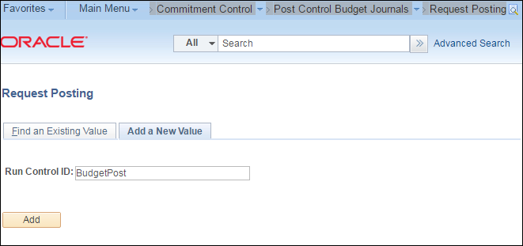

Action | Change Process Frequency to ‘Always’; Enter Description; Enter Business Unit;  Enter the Journal ID.

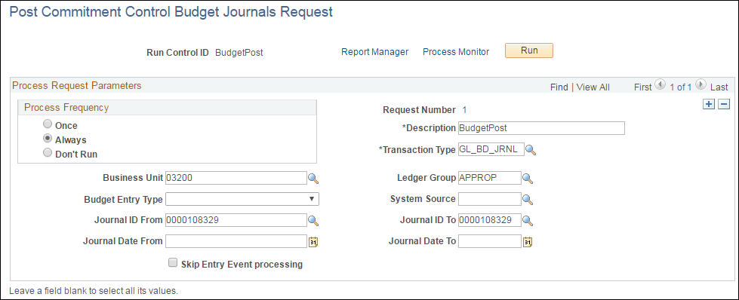

Action | Check Comm. Cntrl. Budget Processor and OK
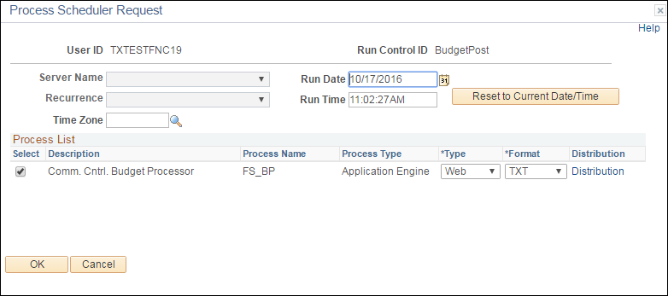

Action | Process Monitor: Process will go to Success.  Select Go back to Request Posting

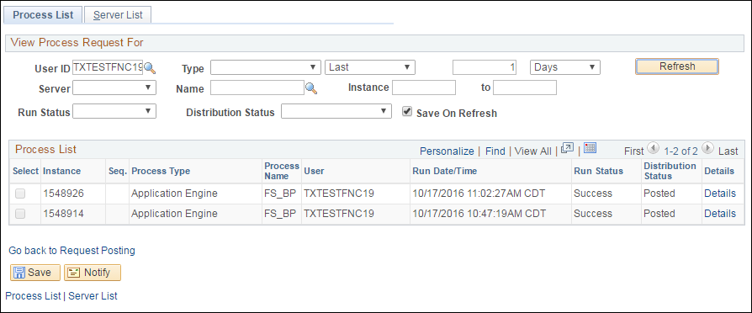

Step 6 | Return to Journal to verify it is posted.

