Change an Asset Location
- Navigation: Main Menu > Asset Management > Asset Transactions > Owned Assets > Basic Add
- Enter: Business Unit, asset ID or any other search criteria, then Search. The asset General Information page is displayed.
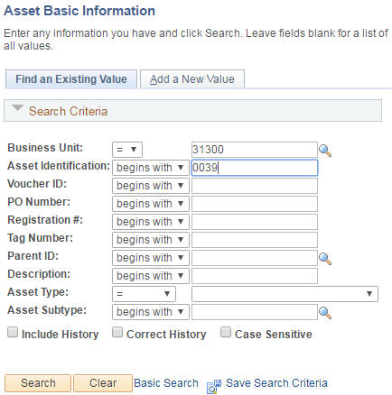
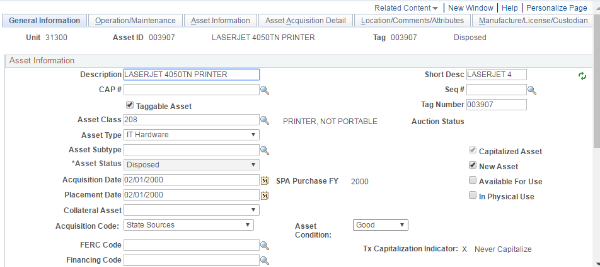

- Navigate to Location/Comments/Attributes tab to change an asset location. Click the “+” icon in the upper right hand corner of the “Location” section.

- When a new location is added, the count of the locations is changed from “1 of 1” to “1 of 2”. The Effective Date defaults to today’s date. Select a new location using the Location field lookup icon. The new location code and the location description are displayed.

- Press the Save button to save the updated location.

