Asset Cost Adjustment/Transfers
- Navigate to: Main Menu > Asset Management > Asset Transactions > Financial Transactions > Cost Adjust/Transfer Asset
- Enter Business Unit and asset ID # that you want to adjust, click Search

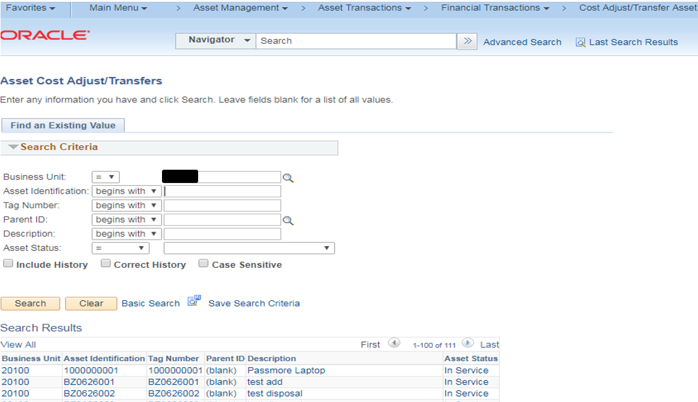

- In the ‘Action’ field on the Main Transaction page, select the adjustment from the drop down list. Click the GO button. The Cost Information page will be displayed.

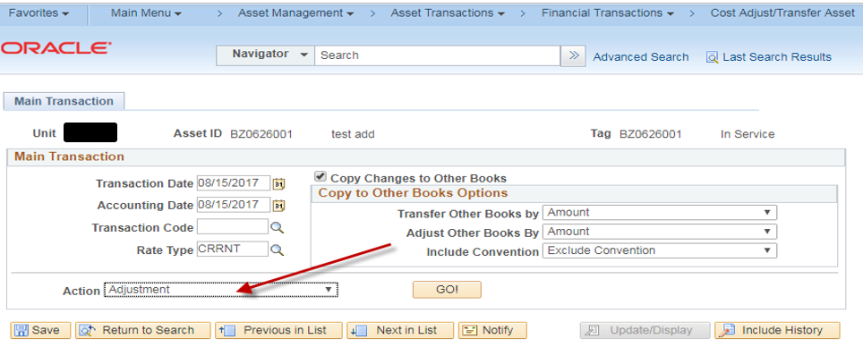

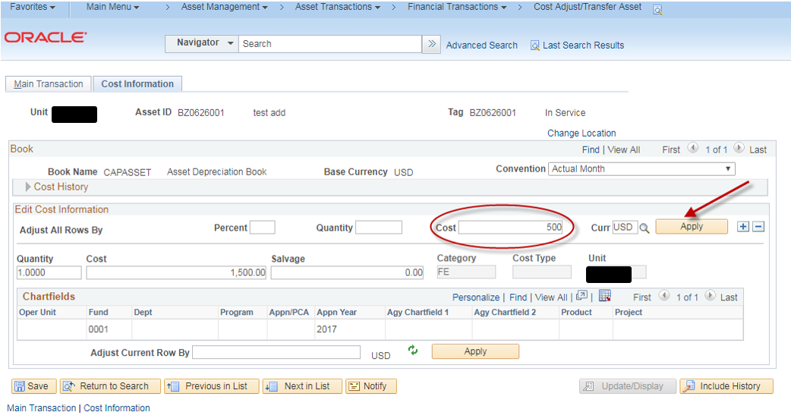

- In the ‘Edit Cost Information’ section of the page, there is a field, ‘Adjust All Rows By’. In this field, enter the additional amount you want to add. Then click Apply. In our example, we added $500.00 and the asset cost increased from $1,500 to $2,000. Save the change.
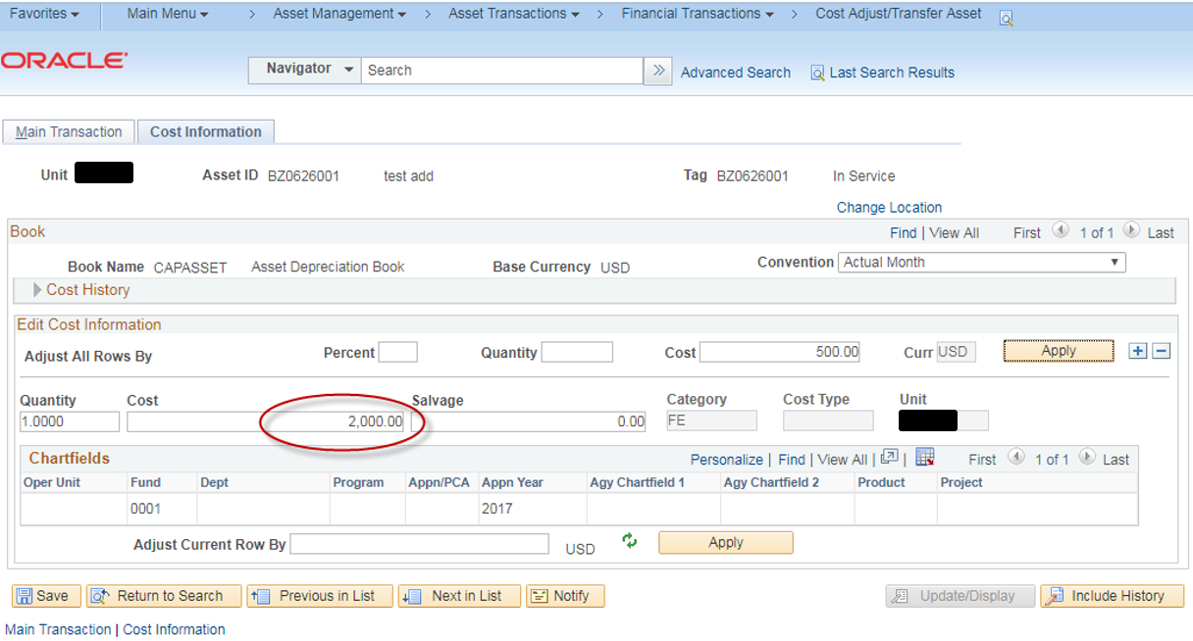
- In our example, we added $500.00 and the asset cost increased from $1,500 to $2,000. Save the change.

